**Fishbone Analysis**

**The Opportunity of Deployment of SPM [Sustainable project Management]**

**In International Projects**

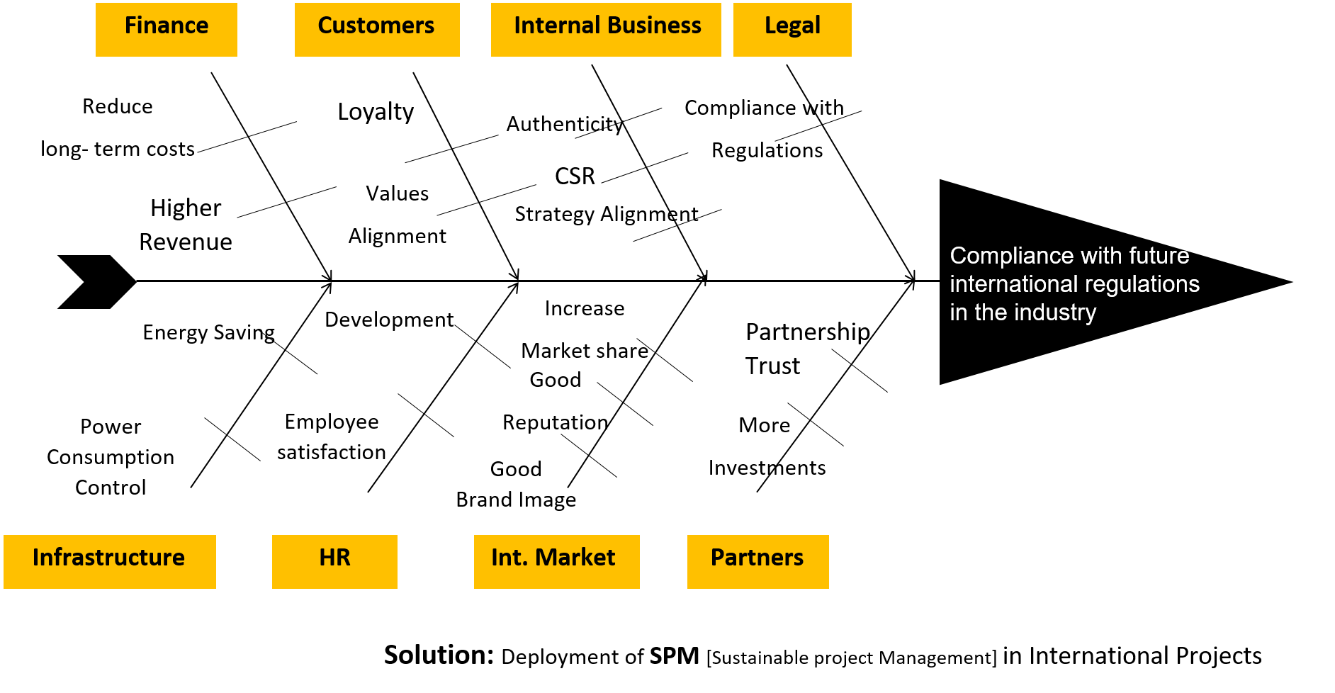

Deployment of

**SPM**[Sustainable project Management]

in International Projects